SCUBA-2 Block Specification
reply_translator

8/6/2004 12:14:00 PM
Table of Contents

1. Block Overview 3
1.1 Block Location and Block Interface Within System 3
1.2 Overview of block 3
1.2.1 Cmd_queue Block Operations 3
1.2.2 Reply_queue Block Operations 4
1.3 Block Dataflow 6
2. Block Interfaces 8
2.1 Interface Signal Description 8
2.2 Interface Protocol and Timing 10
3. Files of the Block 12
3.1 Source Code 12
3.1.1 reply_translator.vhd 12
3.2 Header Code 12
3.2.1 issue_reply_pack.vhd 12

Block Overview
This main functions of this block are to:
- Parse macro-ops received from the cmd_translator
- Generate micro-ops based on the macro-ops received, and insert them in the micro-op queue.
- Send micro-ops across the bus backplane at their scheduled times.
- Retire micro-ops that have sent by removing them from the micro-op queue.

Block Location and Block Interface Within System
This block is located on the clock card FPGA. It interfaces with the following blocks on the clock card:
- cmd_translator
- reply_queue
- bus_tx/dispatch

Overview of block
Macro-ops are generated by the cmd_translator and passed on to the cmd_queue. Macro-ops are generated either by receiving a command from Realtime Linux computers, or by an internal FSM that monitors the status of the electronics and can power down if necessary. Both of these types of commands are tagged differently, but are processed in an identical fashion by the cmd_queue.
The cmd_queue acts as a micro-op generator for macro-ops passed on to it from the cmd_translator. It treats certain macro-ops differently based on their parameter-id. For example, get_status or get_data macro-ops generate several micro-ops in response (these are the only two that are treated specially). Each of the micro-ops generated serve to accomplish the overall task that was requested by the macro-op.
Other than the two aforementioned macro-ops, all other micro-ops are treated the same and generate only one micro-op. Generally speaking, the cmd_queue acts as a command traffic manager.

Cmd_queue Block Operations
In addition to a command-queue (which acts a central repository for micro-ops as they are executed in the system) there are four FSMs that exist in the cmd_queue block:
- Generate:
The Generate FSM receives macro-ops from the cmd_translator. It will remain idle until it detects that a macro-op is available from the cmd_translator (cmd_translator asserts macro_instr_rdy_o). The Generate FSM will then notify the Insert FSM that a macro-op is ready to be inserted if there is space in the queue.

- Insert:
The Insert FSM adds micro-ops to the cmd_queue when it is notified to by the Generate FSM. The Insert FSM assembles header-data received from the cmd_translator in two 32-bit words in a format outlined in BBInstructions.xls. Following the insertion of the two header-words, the Insert FSM will assert the mop_ack_o signal to the fibre_rx to acknowledge that the header information for the micro-op has been inserted. Following this, if there is data to be inserted with the micro-op, the fibre_rx block will begin clocking data through to the Insert FSM which is inserted in the cmd_queue following the two header words. The micro-op is then complete, and ready to be issued during the appropriate sync-pulse.

- Send
The Send FSM transmits micro-ops from the cmd_queue over the bus backplane via the lvds_tx block. It waits until the appropriate sync pulse to issue each command, based on the send-sync-pulse value that is embedded in the two header-words at the beginning of each micro-op in the cmd_queue. If the Send FSM deems that the micro-op that it is to send has expired, then it discards that micro-op. As the words of the micro-op are clocked out of the cmd_queue to the lvds_tx block, each word is also used to generate the micro-op’s checksum. After the command has been completely transmitted, the checksum is also complete, and is appended to the micro-op

The checksum is generated by the Send FSM rather than the Insert FSM because it takes the lvds_tx some time to clock each of the micro-op’s 32-bit-words out over the bus backplane – enough time to allow the checksum generator to parse a word and return to idle before lvds_tx has finished. If the Insert FSM generated the checksum, its generation would be the speed-limiting step, because the checksum is generated serially but the Insert FSM appends words in parallel to the cmd_queue. Thus, the Insert FSM is much faster than the checksum generator, but the Send FSM is not.

- Retire
The Retire FSM waits to receive notification from the reply_queue that a micro-op has finished executing, and can be removed from the cmd_queue. The Retire FSM need not be notified whether a micro-op has executed successfully in the MCE or not, because it will generally be too late to issue a duplicate micro-op to recover from the error. The timing between sync pulses is prohibitively short.

The reply_queue will receive responses to micro-ops from the lvds_rx modules. As the reply_queue does its business, the cmd_queue will put valid data on its uop_o line, and assert the uop_rdy_o signal to indicate the next micro-op to retire. As responses are received, the reply_queue will compile the data for the micro-op assembled into a format understood by the reply_translator. Once a reply packet has been amalgamated, the reply queue will assert its uop_ack signal to the cmd_queue indicating that a single data packet has been assembled, and that the micro-op that generated that response can now be retired from the cmd_queue. The cmd_queue then will retire the micro-op and de-assert the uop_rdy_o line for at least one clock cycle. Once the uop_rdy_o line has been de-asserted, the reply_queue is then free to release the response to the reply_translator for transmission through fibre_tx.

Reply_queue Block Operations
In general, the reply_queue will monitor the uop_o and uop_rdy_o lines from the cmd_queue to learn what the next micro-op response should be. When the cmd_queue asserts uop_rdy_o, the reply_queue assumes that the uop_o bus has valid data on it, and actively waits for responses to return from the various cards that were addressed by the micro-op over the lvds_rx lines. As responses arrive, the reply_queue assembles them into a single data packet in reply to the micro-op that generated the responses. When the data packet is complete and ready to be transmitted to the reply_translator, the reply_queue asserts uop_ack to notify the cmd_queue to retire the current micro-op and move on to the next one.
There are 3 possible error conditions that the reply_queue needs to handle:
- A reply that it receives has already timed out. This indicates that a reply took longer than expected to execute, and that its proper execution in the system is suspect. This does not indicate that the command was issued late, because only commands that have NOT expired are issued by the cmd_queue. Thus, if a reply is assembled by the reply_queue, and it asserts the uop_ack signal to the cmd_queue while the reply has already expired, then the reply_queue will set a flag to the reply_translator that the response is in error. However, the cmd_queue will proceed as usual, and need not know that the reply failed, because there is not enough bandwidth in the system to re-issue a command if it has already expired. It will be left up to the Realtime Linux PCs to determine what to do with the error response that the reply_translator then sends it (through fibre_tx).
- A reply has an incorrect checksum. This indicates that there was a transmission error over the bus backplane from the dispatch block to the reply_queue block. This does not indicate that the error occurred on the length of backplane from the cmd_queue block to the dispatch block, because the dispatch block drops bad packets, and re-synchronizes on the next packet.
If a packet is received by the reply_queue and has an incorrect checksum, the reply_queue will discard the entire reply that the packet contributes to. Because the packet is untrustworthy, the reply_queue cannot use any information from it to generate an error response. Instead, it will use the micro-op data asserted by the cmd_queue on its uop_o bus to generate a valid error response to the reply_translator.
- If the bus backplane receivers/transmitters drop a packet at any point in the system, the reply_queue will not receive a response that it’s looking for based on what the cmd_queue shows on its uop_o bus. In this case, if a reply arrives from a card that the reply_queue is expecting another reply from (this is the only condition that guarantees that data packets were dropped, and that the reply_queue can legally generate a response without being confused by a valid response later), the reply_queue will use the micro-op data asserted by the cmd_queue on its uop_o bus to generate a valid error response to the reply_translator and retain the data packet that it has assembled and compare it to the next micro-op that the cmd_queue asserts on the uop_o bus. The only way that this can work properly is if replies retire in order of dispatch – otherwise the cmd_queue has no way of determining what command was dropped.

.

Block Dataflow

to fibre
from fibre
fibre_rx
…
frame #
macro seq#
macro instr
cmd_translator
cmd_queue
macro seq#
μ seq#
μ instr
0
rp→
ip→
rp→
ip→
rp→
ip→
1
2
bus_tx (LVDS)
bus_rx (LVDS)
bus_rx (LVDS)
from AC
from BC
from CC
reply_queue
reply_translator
fibre_tx
1
3
2
8
4
6
7
:
:
ack
Figure 1 Details of the Issue/Reply Block

5

Figure 2: Data flow for reply_translator

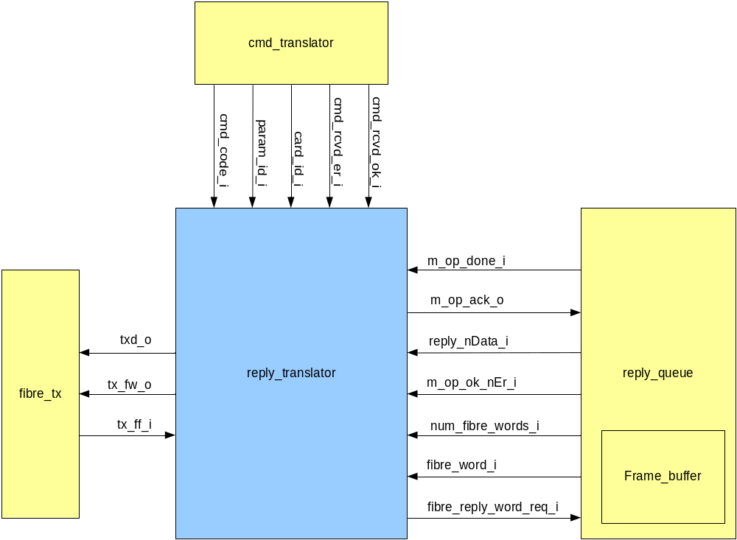

Block Interfaces

Interface Signal Description
uop_status_i : in std_logic_vector(UOP_STATUS_BUS_WIDTH-1 downto 0); -- Tells the cmd_queue whether a reply was successful or erroneous
uop_rdy_o : out std_logic; -- Tells the reply_queue when valid m-op and u-op codes are asserted on it's interface
uop_ack_i : in std_logic; -- Tells the cmd_queue that a reply to the u-op waiting to be retired has been found and it's status is asserted on uop_status_i
uop_discard_o : out std_logic; -- Tells the reply_queue whether or not to discard the reply to the current u-op reply when uop_rdy_i goes low. uop_rdy_o can only go low after rq_ack_o has been received.
uop_timedout_o: out std_logic; -- Tells that reply_queue that it should generated a timed-out reply based on the the par_id, card_addr, etc of the u-op being retired.
uop_o : out std_logic_vector(QUEUE_WIDTH-1 downto 0); --Tells the reply_queue the next u-op that the cmd_queue wants to retire

- Interface Signals
Signal | Description | Direction
Global Signals
sync_i | Delimits the frames periods | in
sync_num_i | Determines when and when not to issue micro-ops | in
clk_i | Global clock signal (50 MHz) | in
rst_i | Global asynchronous active-high reset | in
Signals to/from lvds_tx
tx_o | Serial LVDS output line from the lvds transmitter | out
clk_200mhz_i | Serial LVDS block fast clock | In
Signals to/from cmd_translator
card_addr_i | The card address of the macro-op | in
par_id_i | The parameter id of the macro-op | in
data_size_i | The number of 32-bit words of data in the macro-op | in
data_i | Data belonging to a macro-op | in
data_clk_i | The data clock that fibre_rx uses to clock data into the cmd_queue. There are restrictions on how fast the data clock can be to allow the cmd_queue to store each 32-bit word of data. | in
mop_i | Macro-op sequence number | in
issue_sync_i | The issuing sync-pulse sequence number | in
mop_rdy_i | Tells cmd_queue when a macro-op is ready | in
mop_ack_o | Tells the cmd_translator when cmd_queue has taken the macro-op and is ready to receive data | out
Signals to/from
reply_queue
uop_status_i | Tells the cmd_queue whether a reply was successful or erroneous. Must be valid when the uop_ack_i signal is asserted by the reply_queue. | in
uop_rdy_o | Tells the reply_queue when a valid micro-op code is asserted on it's interface | out
uop_ack_i | Tells the cmd_queue that a reply waiting to be retired has been found and it's status is asserted on uop_status_i and it’s header is asserted on uop_header_i. | in
uop_discard_o |  | in
uop_header_i |  | in
uop_o |  | in
 |  | in

Interface Protocol and Timing

Files of the Block

Source Code

reply_translator.vhd

Header Code

issue_reply_pack.vhd

